Website for the model.

SUMMARY

Concept:
The model is basically a list of countries with associated numbers (e.g. Readiness, Vulnerability). There numbers are calculated aggregating ~30 Indicators.
The website has to show “iconic” results for the general audience (rankings, plots, maps) but also in depth information by country, sector, time and/or region for scientist, economist and interested parties.

#OpenData, #OpenSource as much as possible.

What we are doing:
- We are developing a model to rank countries among several categories that sum up ~30 variables and 1.e4 numbers (most are time dependent). Sometimes we need to interpolate the data.
- We combine them and we get 3 numbers for time-dependent matrix (Hans Rosling GapMinder idea) or maps.
- We also produce iconic results. E.g. into 2 numbers, for a static iconic GaIn™ matrix, or into a single number to create a GaIn™ Ranking.

How we do it (now):
- Everything lives in Google Docs Spreadsheets. We find it the best approach for now because of its accessibility, transparency and the ability to collaborate with others.
- Rankings and visualizations are embedded via Interactive Charts (that are also available via Google Charts Tools API).
- For maps we export the data and use other tools like geocommons.com (we are not very happy with its performance).

What we want: A Webpage for the model that has: (I am thinking Drupal)
- Technical documentation pages for the model (statics).
- Database of papers (1000ish) by tags, sectors, source. May be also ratings and comments.
- Database to store all Indicators (~30). Allow tags to data cells (e.g. Raw/Interpolated)
- Allow to access Database to update it or insert interpolations (via Drupal or other means). Also export to work with it and re-import.
- Do simple mathematical operations on DBs. (+-*/ across countries/time/Indicators). This is all we need for the model.
- Iconic products: Rankings using simple operations and filters merging DBs. (by sector, by change, by region, …)
- Drilling down: Show map/plots/chart by country/sector/time. This means cutting the Indicators DB on several dimensions. For example one page per country pulling the data for that country.
- Allow public/private feedback on each page.
- All data is freely available, downloadable. OpenAccess, OpenData.
- Add media/social layer (Twitter, Facebook, …)
- News and updates.

Timeframe:
Production site with minimals by August.

Screenshots:

Layouts:
The Layout of the webpage to be very similar to:
data.worldbank.org
The country/sector specific pages to have similar layout as: http://sdwebx.worldbank.org/climateportal/home.cfm?page=country_profile&CCode=COL

Global Adaptation Institute
Drupal Website
Request for Proposals
May 27, 2011

Project Summary

The Global Adaptation Index (GaIn™) measures two main concepts: First, the Vulnerability of a country to the effects of climate change and other global trends, and second, the Readiness of a country to successfully implement adaptation solutions. The Index currently consists of (~30) indicators taken from a variety of data sources that are aggregated into 2 scores (one for Readiness, one for Vulnerability). The model also produces a single global score aggregating these two, leading to a Ranking table.

Audience

The GaIn™ model is intended to be a tool that decision makers in both the private and public sectors can use to save and improve the quality of lives.

The Global Adaptation Index, GaIn™, is being developed by the Global Adaptation Institute http://www.globaladai.org/ as a tool to help leaders in the public and private sector identify adaptation needs and opportunities, and to implement urgent actions to increase the readiness of those countries to adapt effectively.

Legacy Site Structure and Content

Our existing model lives in Google Docs Spreadsheets (do not circulate link bsan.eu/Gain_v05 ). The next implementation v0.6 is the one we want to have on the website. We are actively developing it now (do not circulate link bsan.eu/Gain_06 ). We expect to migrate this content to the Drupal site.

The organization of information will probably need to be restructured in order to make work within the Drupal framework. We are open to input on categorizing information so that it makes sense in terms of CCK, Taxonomy, OpenLayers, MapBox and Views (or other modules). GaIn™ is specifically looking for guidance on this issue from our developer. Once we have developed the site architecture, we will tag content appropriately.

The Model

Computation steps:

1. Each Indicator is converted into standardized scores (z-value) within available countries, for each year.

2. Standardized scores for each Indicator are weighted and aggregated (sum).

3. Since summed vulnerability scores can be negative, Vulnerability scores for all countries are equally shifted to make the most negative country score equal to zero.

4. The overall GaIn™ ordinal ranking is calculated as Readiness minus Vulnerability

6. We also produce expected values based on the trajectory.

Scope Of Work:

Migration Table of Work:

Vendors will note the primary task is re-create the GAIN functionality in Google Docs with Drupal.

We have broken down process down into the following steps, along with proposed Drupal module/ capabilities. The below is provided more as a roadmap and general outline than a hard and fast design document. GAIN specifically requests input and feedback on how the goals may accomplished using Drupal.
Task | Drupal Tool (Proposed) | Resources | Cost
1. Technical documentation pages for the model. (Static html. GAIN will do this in house.) | Drupal Book Module or similar
2. Database of papers (1000ish total, 50 to start) by tags, sectors, source. May be also ratings and comments. | MySql, Drupal, Taxonomy
3. Database to store all Indicators (~30). Indicators have ~200 countries and ~10 years of data. Allow tags to data cells (e.g. Raw/ Interpolated) | MySql, Drupal, Taxonomy
4. Allow to access Database to update it or insert interpolations (via Drupal or other means).  Also export to work with it and re-import. Do simple mathematical operations on DBs. (+-*/ across countries/ time/ Indicators). This is all we need for the model. | Drupal CCK and Views, to start
5. Iconic products: Rankings using simple operations and filters merging DBs. (by year, sector, by change, by region. | Drupal OpenLayers, MapBox, TileMill?
6. Drilling down: Show map/plots/chart by country/sector/time. This means cutting the Indicators DB on several dimensions. For example one page per country pulling the data for that country. | Drupal OpenLayers, MapBox, TileMill?
6. Allow public/private feedback on each page | Drupal Comments module
7. All data is freely available, downloadable. | Drupal Export CSV Module
8. Add media/social layer (Twitter, Facebook). Will probably do this in house) | Plenty of Social Media Modules
9. News and updates | RSS, Views, lots of options available

3, 4 and 5 may require some PHP programming. Prior to installing and designing the components for these steps, it would be useful to visualize the final output.

Graphic Design

GAIN already has a theme and look. We are more interested in functionality, but we would like the GAIN site to look similar to www.globalai.org. We will provide theme files if needed. We have existing logos. We have a few regular fonts that we tend to use, and all our Drupal-based sites will have a similar theme. We will also have a color palette. We don't have an in-house graphic designer, however we do have source files (EPS, etc.) for most logos and images which we can repurpose or redesign as needed.

Design/Look and Feel

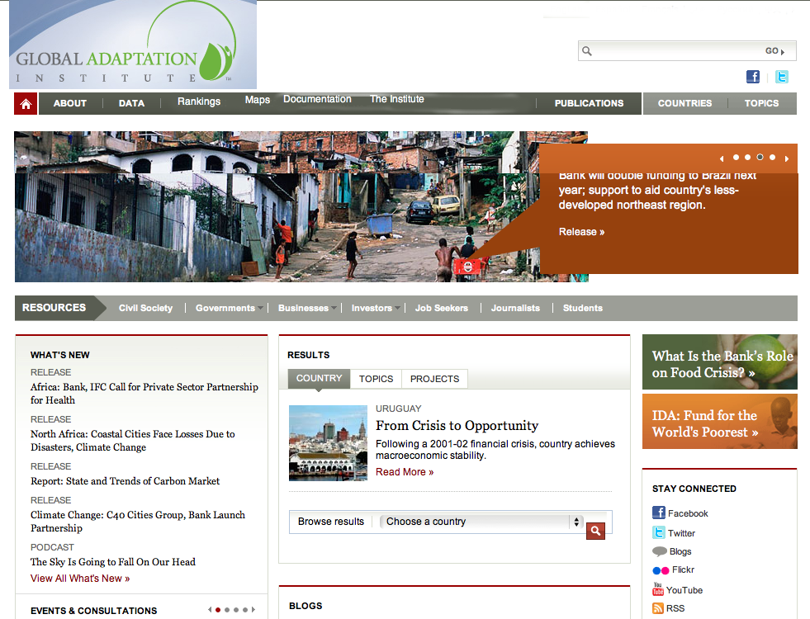

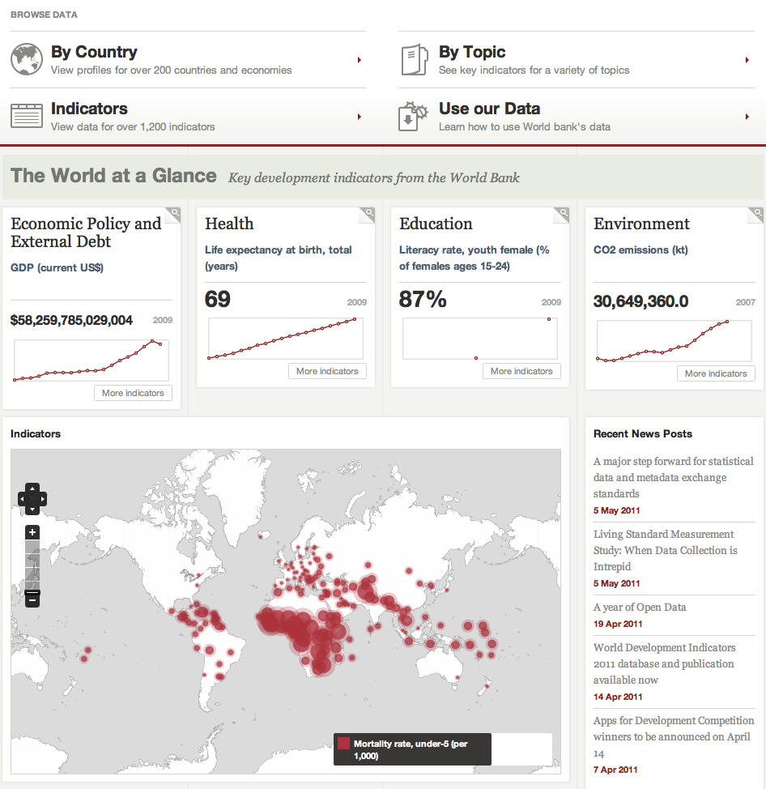

Budget

I. Design

II. Development

III. Testing

Please list out the costs or cost ranges for each phase of the project.

Vendor Selection Criteria

When selecting a vendor for this project, we will be evaluating candidates on the following criteria:

· Experience with Drupal

· Experience building similar Drupal utilizing CCK, Taxonomy, OpenLayers, MapBox, TillMill, custom Views +- other modules

· Experience with creating sites that build communities and have interactive features (blogs, discussion forums, etc.).

· Experience working with nonprofit organizations

· Solid information architecture skills for organizing content in ways that are intuitive to the site visitor

Contact Information

Please direct all responses to this RFP and/or any questions to:

XX

We would like to have all proposals by no later than DATE so we can make a decision to go with a specific vendor by LATER DATE.

